**Lesson Notes**

1. What is the main purpose of an Operating System?

The main purposes are (1) manage the computer's resources, such as the central processing unit, memory, disk drives, and printers, (2) establish a user interface, and (3) execute and provide services for applications software.

1. What is the difference between Operating System Software and Use Application Software?

The difference between operating system and application software is that an operating system is a system software that works as the interface between the user and the hardware while the application software is a program that performs a specific task.

1. What is the difference between Operating System Software and Computer Hardware?

The difference between (OPS) and computer hardware is that a operating software is a system software that works as the interface between the user and the hardware and the computer hardware is

1. What are the main parts of an Operating System?

The Main parts are:

* Process management.
* Interrupts.
* Memory management.
* File system.
* Device drivers.
* Networking.
* Security.
* I/O.

1. What are some popular operating systems?

* Microsoft Windows. ...
* Apple iOS. ...
* Google's Android OS. ...
* Apple macOS. ...
* Linux Operating System.

**Reference Diagram**

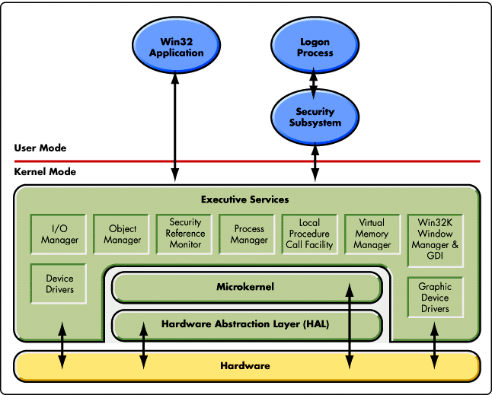

**Student Questions**

1. What is a device driver?
   1. Provide a brief summary

A device driver is a computer program that operates or controls a particular type of device that is attached to a computer.

* 1. List some devices that require a device driver.

Typical devices are keyboards, printers, scanners, digital cameras and external storage devices. Each of these need a driver in order to work properly.

* 1. Provide a label on the reference diagram for the location of a device driver for your graphics card.
  2. Provide a label on the reference diagram for the location of a device driver for a locally attached printer.

1. What is a DLL?
   1. Provide a brief summary

A DLL is a Dynamic-link library is Microsoft's implementation of the shared library concept in the Microsoft Windows and OS/2 operating systems. These libraries usually have the file extension DLL, OCX, or DRV.

* 1. Explain how DLLs are related to user application programs

DLLs are related to user application programs because

* 1. Provide a label on the reference diagram for the location of a DLL

1. What is a windows manager?
   1. Provide a brief summary

A window manager is system software that controls the placement and appearance of windows within a windowing system in a graphical user interface.

* 1. Explain how a windows manager is related to user application programs
  2. Provide a label on the reference diagram for the location of a DLL

1. What is the windows task manager?
   1. Provide a brief summary
   2. List and explain four (4) types of system information provided by the task manager
   3. Provide a label on the reference diagram for the operating system components related to each type of information.